Science Behind Methods for Retraining your Brain away from Chronic Pain

## Compiled by Paul Hansma PhD, Researcher in the Neuroscience Research Institute, Faculty in the California NanoSystems Institute and Emeritus Professor in the Dept. of Physics, all at UCSB; a founder and the chief inventor at Active Life Scientific and former chronic pain sufferer.

### Overcoming chronic pain requires overcoming a brain problem (cerebral processes) in addition to a body problem (nociceptive input).

## The Brain Problem of Chronic Pain

Recent breakthroughs suggest that intense chronic pain can be greatly reduced or even eliminated by training your brain. The only cost is effort! A 2016 Nature article states: “Cerebral processes contribute to pain beyond the level of nociceptive input and mediate psychological and behavioural influences… Here we use functional magnetic resonance imaging combined with machine learning to develop a multivariate pattern signature—termed the stimulus intensity independent pain signature-1 (SIIPS1)—that predicts pain above and beyond nociceptive input” [Woo].

This breakthrough article provides convincing scientific support to the ideas that have already helped thousands overcome chronic pain: specifically, that chronic pain is not just a result of “nociceptive input” and must also be dealt with as a brain problem. Chronic pain can have a life of its own in the brain independent of input from the nociceptors (pain sensors) in the body. The article [Woo] builds on related experimental work of other groups that had previously shown that chronic pain involves different brain areas than nociceptive pain [Vachon-Presseau] [Hashmi][Baliki 2014]. It is consistent with recent theoretical work that describes pain as an emergent phenomenon related to activity in large-scale networks that include non-nociceptive regions [Kucyi] [Farmer].

It is also consistent with 2016 work from [Europe](http://journal.frontiersin.org/article/10.3389/fnins.2016.00121/full) and [Japan](https://www.ncbi.nlm.nih.gov/pmc/articles/PMC4870631/pdf/srep26181.pdf) on human neurons grown in small dishes that contain Multi-Electrode Arrays (MEAs) [Odawara][Amin]. This work reveals that human neurons will fire spontaneously and excite each other into activity without any external stimulus! That is fine if they are in the small dishes just doing their thing. It is not fine if they are in your brain generating the experience of pain! The photos of the MEA and human neurons below came from Morgane Audouard, Carolina Camargo, Jiwon Jang, and Ken Kosik, with whom I am privileged to collaborate. They have confirmed that human neurons will fire spontaneously and excite each other into activity without any external stimulus.

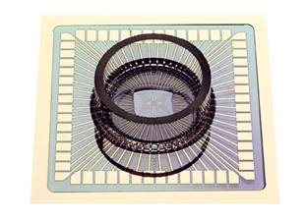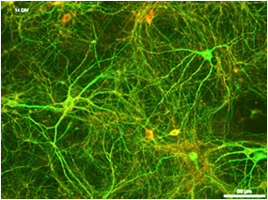

Perhaps most important, because it points to the possibility of learning how to overcome chronic pain by learning how to activate helpful brain regions, is that stimulus intensity independent pain signature-1 (SIIPS1) confirmed previous experimental evidence that activity in one brain region (a shell-like region surrounding the nucleus accumbens) increased pain while activity in another brain region (a core-like region inside the nucleus accumbens) reduced pain [Baliki 2013][Baliki 2010][Ren][Lee 2015].

Further support for the need to deal with the brain problem in order to overcome chronic pain comes from a 2016 review in Science that stated: “*Phenomena such as placebo analgesia or pain relief through distraction highlight the powerful influence cognitive processes and learning mechanisms have on the way we perceive pain. Although contemporary models of pain acknowledge that pain is not a direct readout of nociceptive input, the neuronal processes underlying cognitive modulation are not yet fully understood”* [Wiech].

The placebo effect is very strong for chronic pain and has been investigated by Tor Wager’s group in some detail. In their 2004 Science article they reported: “*In two functional magnetic resonance imaging (fMRI) experiments, we found that placebo analgesia was related to decreased brain activity in pain-sensitive brain regions, including the thalamus, insula, and anterior cingulate cortex... a major portion of the placebo effect may be mediated centrally by changes in specific pain regions. This account acknowledges that pain is a psychologically constructed experience that includes cognitive evaluation of the potential for harm and affect as well as sensory components*” [Wager]. So here again we have hard science showing that chronic pain is a brain problem in addition to whatever body problem may exist [Rainville]

Unfortunately, pain transitions smoothly from being only a body problem associated with damage to body tissue (nociceptive pain) to being also a brain problem (a cerebral process) if it persists for months or years. Despite the breakthrough research using fMRI in a laboratory setting, there are presently no practical devices to measure either the body problem or the brain problem. Therefore this transition is invisible not only to patients, but also to medical professionals. Every chronic pain sufferer that I have met is firmly convinced that their pain is a body problem. After all, it started as a body problem and, years later, the pain is still felt in the body where it started, eg. the lower back. So it is natural to assume that the problem, like the pain, is the same. It is only after this misconception has been corrected that the chronic pain sufferers have been able to use brain-based therapies and recover.

An additional problem is that physicians, who are educated and skilled in dealing with body problems, are not educated and skilled in dealing with brain problems. Sometimes, even if the physician knows enough about chronic pain to know that dealing with the body is not the answer for a particular patient and advises the patient to try a brain based approach from a psychologist or psychiatrist, the patient insists on one more surgery or other body-based therapy! Thus many chronic pain patients continue to receive body-based therapies instead of the brain-based therapies that they need to recover. Curing a brain problem with a body-based therapy can only work **indirectly** through the placebo effect, which is strongest for surgery, then injections, and then prescription drugs with strong side effects. Fortunately there are clinically- tested methods to work **directly** on the brain problem.

The problem of chronic pain is of such enormous personal, social and societal importance that pioneers have already developed useful methods for dealing with the brain problem, even without the aid of a detailed understanding based on hard science that we can hope for in the future. One example is in the next section. More have been collected in the section near the end of this document titled: “Four Useful Methods and the Science Behind Them”. These methods have not only helped thousands of people overcome chronic pain, but can help guide the development of deep fundamental understanding of the cerebral processes that create chronic pain. Hopefully this fundamental understanding will help in developing even more effective, individually-tailored, methods for overcoming chronic pain.

# Chronic Pain Therapy Grounded in Neuroplasticity

One useful method for dealing with the brain problem is based on neuroplasticity, which can undo the takeover of the brain by pain. Neuroplasticity refers to the brain’s ability to change by creating new neural pathways and eliminating neural pathways that are no longer needed, such as neural pathways devoted to chronic pain. Norman Doidge, M.D., eloquently writes about two people's success in chapter 1 of his new book “The Brain's Way of Healing: Remarkable Discoveries and Recoveries from the Frontiers of Neuroplasticity.”

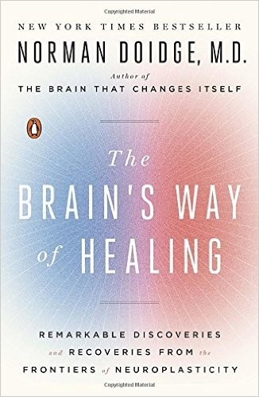 

*This book brings retaining the brain away from pain into the mainstream. It was on the New York Times Bestseller list in 2015 and on Amazon it was the number 1 best seller in neurology in 2016. Over a million copies have been sold.*

## How to overcome chronic pain with visualization, a type of Guided Mental Imagery

The first story in Dr. Doidge’s book is about Michael Moskowitz, M.D.,who, together with Marla Golden, D.O., runs a great website on the topic:  [neuroplastix.com](http://neuroplastix.com/). There, for example, you can see therapeutic animations showing the progression from acute (nociceptive) pain to chronic pain and back. This is the core of the **Visualization Method:** visualizing the yellow areas of brain activity associated with chronic pain decreasing in size (see the brain image on the workbook cover below).

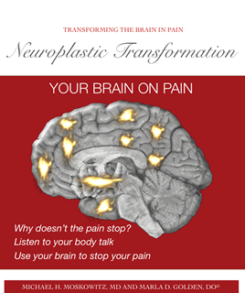

*This workbook by Michael Moskowitz, MD and Marla Golden, DO, is available at* [*neuroplastix.com*](http://neuroplastix.com/)*, is a wonderful resource for retraining your brain away from pain either by yourself or together with a professional practitioner.*

Dr. Michael Moskowitz’s breakthroughs came not only from his retraining and experience as a professional pain practitioner, but also from his personal history of chronic pain. His story is told in wonderful detail in chapter one of Dr. Doidge’s book, which I highly recommend that you read. In outline, a water-skiing accident started 13 years of chronic pain, with average pain of 5/10 (self rating of 5 on a 0 to 10 scale) going as high as 8/10 on bad days and still 3/10 on good days. After he retrained his brain using visualization exercises based on the chronic pain slides now available on [*neuroplastix.com*](http://neuroplastix.com/), he started to get results within a month and in a year was almost always pain free, 0/10! Success for a friend of mine came even quicker, within a few weeks!

Beyond the story of Dr. Michael Moskowitz’s recovery, Dr. Doidge’s chapter is a wonderful background resource and I would highly encourage anyone interested in diminishing his or her chronic pain to read it. It contains many of the key insights that will be discussed below in detail. For example, pain is not simply the brain reporting a painful event from somewhere in the body. In general, the experience of pain is created in the brain when neural pain circuits in the brain become active and the neurons begin firing action potentials, stimulating other neurons in the neural pain circuits to fire. It can become like a chain reaction. The brain can get very good at creating the experience of pain which can run with a life of its own.

A common saying among neuroscientist is: neurons that fire together, wire together. This means that as neurons fire together in producing the experience of pain, they strengthen their connections and can do a better and better job of producing the experience of pain. Repetition of a task like riding a bike or learning vocabulary makes that task easier for the brain. Unfortunately the same is true for producing the experience of pain. If, however, you are able to give the brain a break from having neurons fire together to produce the experience of pain and instead give your brain a different task, such as visualizing the areas of pain in the brain shrinking, the brain will gradually become better at doing those tasks and less good at producing the experience of pain.

The unconscious brain decides whether or not to activate the neural pain circuits. Unfortunately the unconscious brain decides to activate the neural pain circuits in chronic pain even though it is not helpful. Neuroplastic therapy for chronic pain is focused on retraining the (unconscious) brain to learn that it is not helpful to experience chronic pain. Thus, successfully retraining the brain in this way diminishes or eliminates chronic pain.

The second story in Dr. Doidge’s book is also highly informative. In outline, a registered nurse heard the sound of a rubber band snapping and felt something inside of her break, as the full weight of a 280 pound patient damaged all five of her low back discs. She became disabled, in chronic pain. “I was depressed and suicidal, and it didn’t matter what drugs the doctors gave me—the pain never went away. I couldn’t even watch TV or read because, on top of the pain, the drugs I took put me in a gray zone. There was no reason to live.”

Based on his own success, Moskowitz retrained her to be relentless in visualizing the transformation of her brain into the no pain state with his three pictures of the brain [[neuroplastix.com](http://neuroplastix.com/)]. By the fourth week she experienced pain-free periods of 15 to 30 minutes and thought, “This is going to go away.” She was right. After some more work the pain did go away and never came back.

A friend I have known since college–I’ll call her Susan–wrote about her chronic pain from Piriformis syndrome, which involves compression of the sciatic nerve by the piriformis muscle. Her chronic pain was a major factor in her life. I started sending her the information I found on chronic pain and the possibility of dramatically reducing or even eliminating the pain by retraining the brain away from pain.

Within a few weeks she wrote:

*I'm finding this really incredible - and while I'm a bit reluctant to even say anything in case it jinxes the effects - and because it all seems so preposterous - I have to tell you that I looked at the Chronic Pain slides, the* [*neuroplastix.com*](http://neuroplastix.com/)*site, glanced at pieces of online videos and google references and now find myself quite suddenly pain free (or at least pain so diminished as to not be problematic). Wow! I still get small twinges and pain grabs but they are incredibly diminished. I seem to have a pain in my neck and arm, but just thinking about the pain maps in my brain - visualizing the slides, seems to be enormously helpful. This is really encouraging and quite crazy -- extraordinary really! I still feel a bit foolish - as if I have swallowed the Kool Aid and thrown away my crutches.  The truth about that? Who cares! I am walking and bending with relative ease ... Hallelujah.*

## What continuing chronic pain is really like

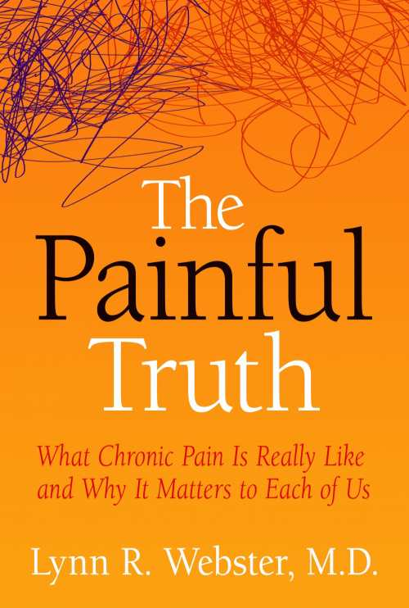

*If you need incentive to begin working on the brain problem, this book is for you. It shows the alternative.*

The stories of recovery from chronic pain in Doidge’s book are in dramatic contrast with the stories in another book, “The Painful Truth: What Chronic Pain is Really Like and Why it Matters to Each of Us,” by Lynn Webster, M.D. Here a compassionate and highly trained pain specialist tells stories of patients who have been treated with painkillers and the loving support of friends and family (while it lasts). One dramatic story starts with a man with a good job, who is happily married to a very loving wife. The chronic pain he experiences from an accident launches the man into a downward spiral. This ultimately ends with abandonment by his wife and children and his suicide. Even the most positive stories in the book end with “acceptance with resilience,” that is, an acceptance that the pain will never go away, but the resilience to lead the most normal life possible with the pain.

There is a growing understanding that long term opioid use for chronic pain can be problematic because of adverse side effects and tolerance [Crow, JM][[Chou]](http://annals.org/aim/article/2089370/effectiveness-risks-long-term-opioid-therapy-chronic-pain-systematic-review). New opioids and new spinal stimulators are in development that may be better alternatives for existing choices [Crow, JM]. Treating pain as a tissue issue is especially useful in the treatment of acute pain to prevent chronic pain from ever developing, but if it does develop, the use of opioids can be counterproductive because they can increase sensitization: make the brain problem worse.

If you are worn down, perhaps by years of chronic pain, and feel that the best you can do is to passively accept help from painkillers and the loving support of friends and family, then the stories in this book may help you generate the energy and commitment you need to work on the brain problem of your chronic pain.

# A more in depth look at chronic pain

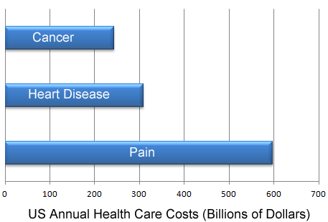

*Pain is not only a huge problem for the sufferers, it is also a huge problem for the nation. [data from Gaskin, DJ]*

What do experts say about chronic pain?  “For some unfortunate persons, pain persists beyond the healing time needed for recovery from an injury, extending indefinitely because of factors that are pathogenetically and physically remote from the originating cause. Often, such pain bears little or no relationship to observable tissue damage. Pain that exists indefinitely under these conditions is chronic pain.” [Chapman and Nakamura] “Chronic pain is often defined as any pain lasting more than 12 weeks. Whereas acute pain is a normal sensation that alerts us to possible injury, chronic pain is very different. Chronic pain persists—often for months or even longer.” [NIH MedlinePlus] “Around 100 million adults in the United States are affected by chronic pain in a single year. The annual total cost of pain, including direct costs, decreased wages and lost productivity, eclipses that of any other condition” [Holmes, David].

*The goal of retraining the brain away from pain is to keep helpful pain, but reduce or eliminate unhelpful pain.*

Pain related to tissue damage is, of course, very useful for survival (here “tissue” refers to all the skin, bones, organs and other stuff that make up a human body). Congenital insensitivity to pain is a serious disease. “From birth, affected individuals never feel pain in any part of their body when injured. People with this condition can feel the difference between sharp and dull and hot and cold, but cannot sense, for example, that a hot beverage is burning their tongue. This lack of pain awareness often leads to an accumulation of wounds, bruises, broken bones, and other health issues that may go undetected. Young children with congenital insensitivity to pain may have mouth or finger wounds due to repeated self-biting and may also experience multiple burn-related injuries. These repeated injuries often lead to a reduced life expectancy in people with congenital insensitivity to pain.” (ghr.nlm.nih.gov/condition/congenital-insensitivity-to-pain)

Pain thus serves not only to alert us that our hand is on a burning surface and thus minimize tissue damage, but also to motivate us to let injured tissues take a break to heal. This type of "nociceptive" pain (pain due to tissue damage) is useful. Chronic pain is not useful! It has no survival value. Chronic pain is basically a brain pathology: neuroplasticity gone wrong. The whole goal of chronic pain therapy grounded in neuroplasticity is to undo the takeover of the brain by pain. Pain is a construct of the brain designed to protect you, but pain becomes useless after sensitization.

Everyone I have met with chronic pain believes that their pain is due to a body problem (or multiple body problems). But there is no way of knowing if this is the case because of the brain problem, which can create pain even with after the body problem is healed.

For all but one person whom I have met that has dealt with the brain problem, it has turned out that there was no significant underlying body problem anymore. Their bodies had healed, but the pain had continued due to the brain problem in the same or nearby location to where it had begun, leading to the confusion. This includes cases of diagnosed long term chronic pain from shingles, from sciatica, from bursitis, and from a galaxy of “abnormalities” seen in X-rays, especially of the lower back. The one exception was from diabetic neuropathy.

Once the brain problem is solved, your chronic pain will be gone or greatly reduced. Any remaining signals coming from the body, such as from an incurable disease like diabetic neuropathy, can then be dealt with by retraining your brain to make better choices about what is in your conscious awareness (distraction) and by reducing the unpleasantness associated with the signals coming from the body with meditation and with affirmations. A very useful affirmation is: “I feel that. It’s of no importance.”

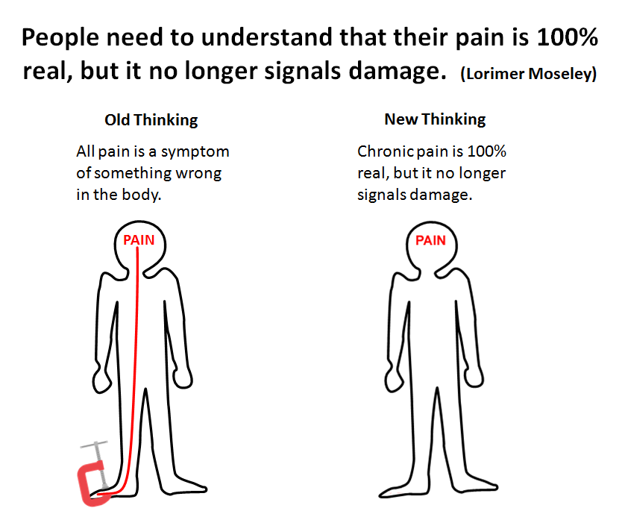

*If the brain experiences enough stimulation from damaged tissue during the nociceptive phase, it learns to create the sensation of pain better and better! It gets better and better at creating and experiencing pain. It can create the sensation of pain from light touch or even in missing limbs!*

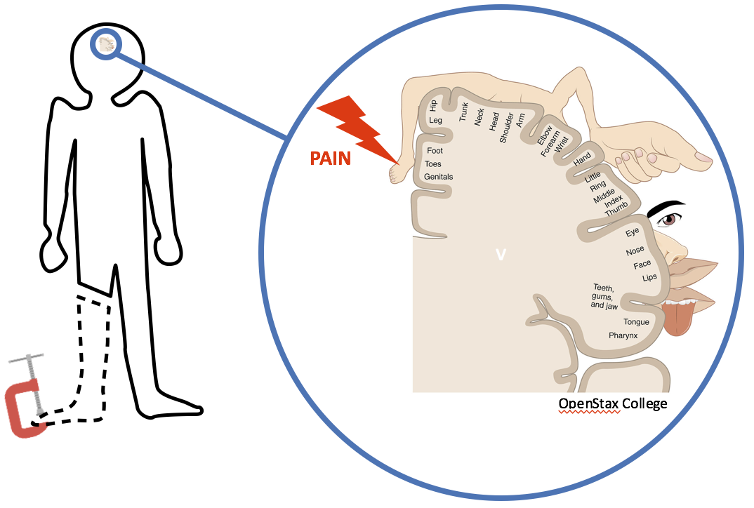

*Phantom limb pain clearly demonstrates that pain felt in a part of the body is actually due to mental processes in the brain that are referred to the body image in the brain. As long as the missing limb remains a part of the body image in the brain, it can still hurt! In this case it is clear that experiencing this type of pain serves no purpose. Mirror boxes, which will be discussed below, have treated phantom limb pain by successfully retraining the brain.*

Dr. Moskowitz, along with Dr. John Sarno, was one of the first to call attention to the idea that understanding chronic pain required tracing it back to the brain. He delineated the anatomy, physiology and molecular biology of brain-based pain. [Moskowitz] There is evidence that as chronic pain persists, it takes over more and more of the brain. [[neuroplastix.com](http://neuroplastix.com/)] Daily pleasures such as having fun and being active become compromised as the brain becomes increasingly focused on chronic pain. The cure, as mentioned in Dr. Doidge's book (based on Dr. Moskowitz’s research), is to retrain the brain away from pain.

## The story of my chronic pain

My chronic pain began with a long day pruning a huge bougainvillea. I ignored the warnings of the acute pain I felt in my elbow by lunch time and worked the whole afternoon. By the evening my elbow really hurt. When it didn’t get better in a week or so I started visiting physicians and physical therapists. As the pain in my elbow got better, my left shoulder started to hurt! Then my right shoulder.

Five years later I had a diagnosis of bursitis and was seeing a physical therapist weekly and doing 15 minutes of physical therapy a day - pushing myself through the pain in hopes of recovering sooner rather than later. When my chronic shoulder pain was at its worst, I tried to “protect” myself by sitting in a recliner with pillows under each arm. I would not lift anything over my head, not do any machining (which I love) or gardening (about which I have mixed feelings!). I slept with 5 pillows and had to wake each time I turned over to rearrange the pillows, interfering with my sleep.

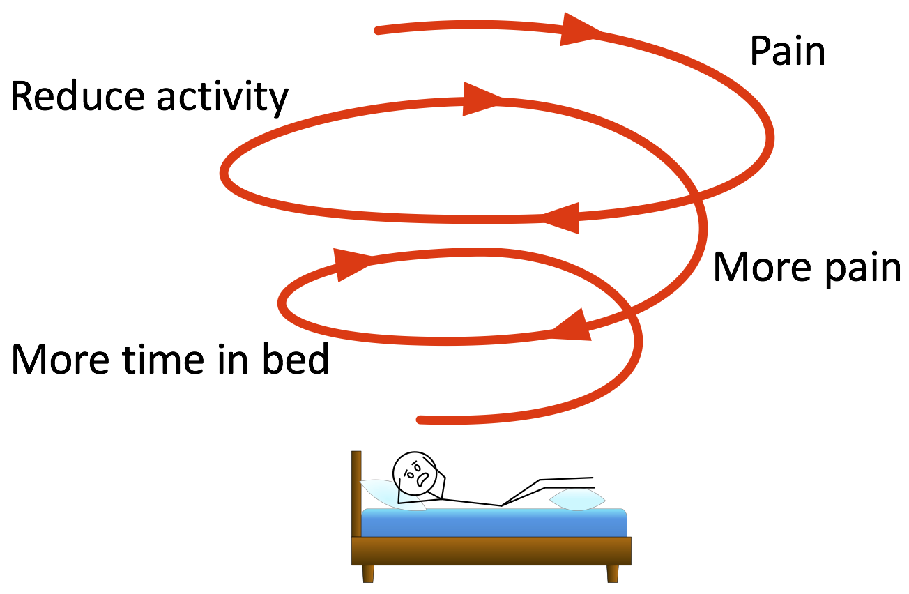

*A downward spiral of pain/inactivity as discussed by Daniel J. Clauw, M.D., in his YouTube video “Chronic Pain – Is it All in Their Head?”*

Pain caused me to limit my activity (good for acute pain, bad for chronic pain). I had more time and fewer distractions from experiencing pain, which lead to further restrictions on activity and more perceived pain. I fell into a downward spiral. Pain leads to inactivity. Without the distraction and mental resources needed for activity, the brain gets better and better at what it can do: pain, which leads to more profound inactivity which leads to more sensitivity to pain, etc.

My general experience is, unfortunately, typical. After experiencing chronic pain for an extended period of time, a person feels pain at levels of stimulation far less than what would cause a “normal” person pain. This is called sensitization. A great deal of research has been done on sensitization right down to understanding it at the level of single cell neurobiology. An overview of this research will be presented in a later section devoted to the science of chronic pain. For now, it is sufficient to note that you will feel pain even from stimuli that do not put you at risk for injury. If you restrict your activities to avoid all pain, you will continue the downward spiral of pain/inactivity.

Understanding the problem was very important, but the real work involved finding ways to reverse the downward spiral and gradually add more activity while experiencing less pain. To get the confidence to undertake this work, it is important to assure yourself that working through some pain to add activity and start to reverse the downward spiral will not affect you detrimentally. This includes visits to doctors and specialists until it is clear that nothing can be fixed. The problem, no matter how it started, is now how to get rid of the chronic pain.

In my case, all of the body based therapies I tried did not really help. Part of the problem I now realize was because of my misunderstanding of how to do physical therapy exercises at home. My physical therapist had told me to just move until the point of pain. With 20/20 hindsight, I now realize I should have heard this as, “You should not have the experience of pain during your home practice.” Instead, I wanted to get better faster so I went to the point of pain and a little beyond in most exercises. This, unfortunately, kept my brain very well practiced in generating the experience of pain in association with physical movement! Better ways to increase physical activity are discussed below.

Finally, on the advice of a wonderful man, Brian Chang, I discontinued the exercises and put my arm in a sling for three weeks, which gave the inflammation in my shoulder time to subside. Meanwhile I was reading the books of John Sarno, M.D., and becoming convinced that my real problem was not with the tissue of my shoulder, but with my brain. While reading his book, “The Divided Mind,” I was sitting in a recliner with pillows under each arm to minimize my chronic shoulder pain when I suddenly noticed pain in my right elbow. Now, I knew that I had done nothing to damage the tissue in my right elbow that day. I found myself saying to my brain: "YOU'VE GOT TO BE KIDDING!" "CUT IT OUT!" The pain in my elbow disappeared immediately.

This breakthrough marked the beginning of the next phase of my recovery from chronic pain. It was the first time I knew for sure and at a very deep level the basic idea that the source of my pain was my brain, and that my brain could be retrained. I was not totally free of pain, but my pain was very much diminished and I could begin the next phase: working toward the elimination of chronic pain.

But it still took about six months until I could do my normal activities with nothing more than temporary tinges of pain. A really helpful practice for me, also suggested by Brian Chang, was Qigong (pronounced chee gong). Qigong movements are graceful and resemble those of Tai Chi, which he also suggested as an alternative. Tai Chi and Qigong both came from China, Tai Chi from martial arts and Qigong from healing arts. I was lucky enough to encounter a wonderful Qigong guide, Joyanna Maria, for a few classes at a retreat, and then started using her DVD (you can get one of hers at [joyqiyoga.com](http://www.joyqiyoga.com/) or find some gentle movement class or video that appeals to you). **I would feel momentary pain during some of the exercises, but it was gone by the end of the session, in part because of the distraction of all the different, gentle types of movement.** It took about six months until I was basically pain free for normal activities including reaching over my head to get things from shelves and using power tools. Recently, about 12 months after my breakthrough, I was able to try standing paddle board for the first time and experienced no shoulder pain!

Though this particular discussion has been in terms of general concepts and my story, there has been some serious and systematic work in this area that will be discussed below.

## From passive to proactive

### 

It is all too easy to become passive from chronic pain—worn down by the stress, the lack of sleep and the fatigue that can accompany chronic pain, going to one doctor after another in hope that the next test, the next drug, the next treatment will finally fix the problem for you or at least give you some relief. You can become resigned to the mistaken beliefs that 1) the best you can hope for your chronic pain is acceptance with resilience, and 2) all you can do is hope that someone else can do something to help you.

But it doesn’t have to be this way. You can become proactive. You have already taken a first step by reading this far in this document. You can continue reading the document and finding out about some of “The Basic Science of Pain.” Or you can jump directly to “Four Useful Methods and the Science Behind Them“. These methods for how to overcome chronic pain all are based on the facts that, 1) chronic pain involves brain processes that are not useful, and 2) the brain can be retrained away from pain.

# The Basic Science of Pain

## A wrong and misleading model of pain

Descartes made a great advance in the understanding of pain, from believing that pain was punishment from the gods to a physical problem. This famous figure describes the pathway for promptly moving one's foot away from a hot flame. In the figure the heat of the flame near the foot activates a fiber within the nerve tubule that traverses up the leg to the spinal cord and, finally, to the brain. Descartes compared this fiber with a cord attached to a bell—by pulling on the other end of the cord, the bell will ring.

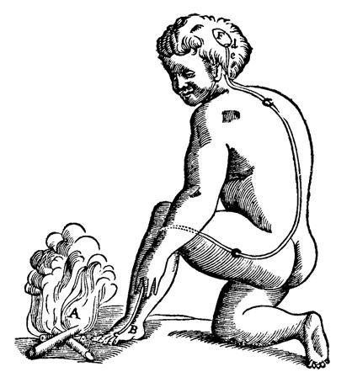

*Learning that this model of pain is wrong and misleading can open your mind to the possibility of retraining the brain to reduce chronic pain.*

Descartes's theory has the advantages of being easy to understand and seemingly having a good correspondence with our experience. It has the disadvantages of being wrong and misleading—especially for people with chronic pain. It is misleading for people with chronic pain because it causes them to focus on tissue problems (remove the foot from near the flame), but ignore the bigger problem, the brain**.** If we update Descartes's picture with more modern understanding we find that the bell can ring by itself! The brain can generate chronic pain with little or no input from tissues.

## The Gate Control Theory of Pain

The Gate Control Theory of pain [Melzack, Wall] revolutionized the understanding of pain. The theory now includes the finding that “the brain can control the degree of pain that is perceived, based on which pain stimuli are to be ignored to pursue potential gains. The brain determines which stimuli are profitable to ignore over time. Thus, the brain controls the perception of pain quite directly, and can be ‘trained’ to turn off forms of pain that are not ‘useful.’ This understanding led Melzack to assert that *pain is in the brain*.” [[en.wikipedia.org/wiki/Gate_control_theory](https://en.wikipedia.org/wiki/Gate_control_theory)]

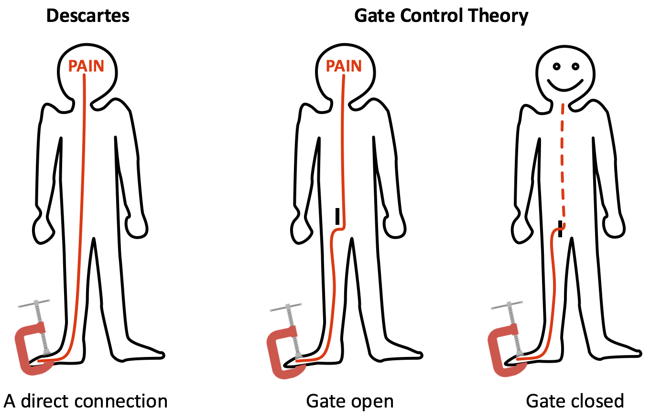

*Descartes had a direct connection from the pain sensors to the brain. The Gate Control Theory [Melack and Wall] has gates that can either transmit the signal from the pain sensors to the brain or not. Only one gate for one nerve fiber is shown here. There are many gates along the spine for the many nerve fibers in the body. There are also more general gates in the brain stem that can inhibit or muffle incoming pain signals from the spine by the production of endorphins, which are morphine-like substances that occur naturally in the human body.*

The Gate Control Theory explained why rubbing a painful area can actually reduce the pain. The signal from the neurons that transmit the sense of touch can close the gate that would otherwise let the pain signal reach the brain, and thus block the experience of pain. The science of this phenomenon (which is much easier to access experimentally than how retraining the brain works) has benefitted from extensive research. An excellent review article concludes, “Pain is not a passive consequence of the transfer of a defined peripheral input to a pain center in the cortex, but an active process generated partly in the periphery and partly within the [central nervous system] by multiple plastic changes that together determine the gain of the system. The understanding of plasticity is rapidly increasing, and we expect that the future will provide further exciting insights into pain mechanisms.” [Woolf and Salter]

Here are two schematic diagrams based on a modern understanding of the Gate Control Theory of pain. There is no need to understand everything about these very complex diagrams... I certainly don’t! I include them to emphasize that there are already known mechanisms that a retrained brain might use to reduce chronic pain. Clearly much more research will be needed to get a detailed understanding of what actually occurs, which might lead to even more effective ways to retrain brains. But the point is that whether or not we have this specific knowledge, these mechanisms do exist...and we can use them!

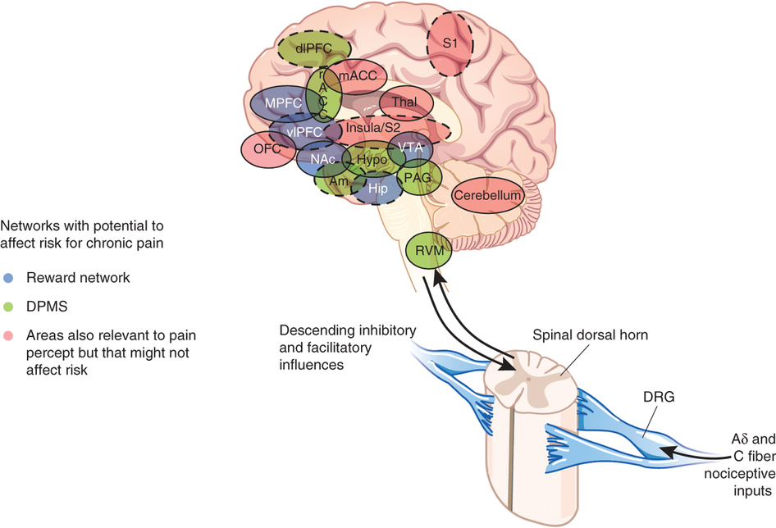*The pain signals from the “A𝛅 and C fiber nociceptive inputs” may or may not be transmitted to the brain depending on the “Descending inhibitory and facilitatory influences” which come from the brain to the “Spinal dorsal horn” which functions as a gate (as in Gate Control Theory of pain). [Denk] Note that there are very many such gates in the human body.*

Signals descend from the brain to modulate the transmission of signals from the pain sensors in the body. Note that these influences can be inhibitory, blocking the transmission of signals from the pain sensors. This is a possible mechanism for the retrained brain to shut off chronic pain. Note also that these influences can be facilitatory, enhancing the transmission of signals from the pain sensors. This is a possible mechanism for the sensitization that will be discussed below in the section “Sensitization and its Reversal.”

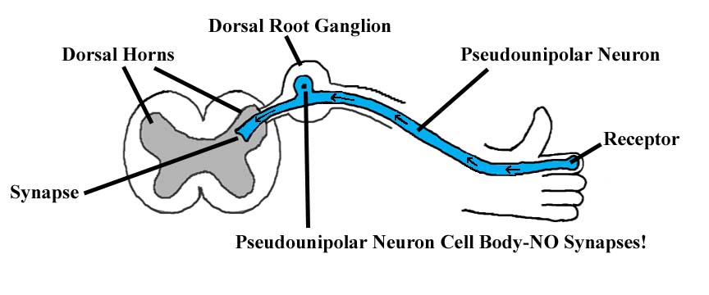

*This schematic shows the gate formed from the Dorsal Root Ganglion going into the Dorsal Horns that will control whether the signal transmitted from the receptor in the finger through the Pseudounipolar Neuron is allowed to pass up the spine to the brainstem or not. (*[*med.umich.edu/lrc/coursepages/m1/anatomy2010/html/modules/spinal_cord_module/spinalcord_10.html*](http://www.med.umich.edu/lrc/coursepages/m1/anatomy2010/html/modules/spinal_cord_module/spinalcord_10.html)*)*

In the brain stem other gates will determine if the signal passes to the brain.

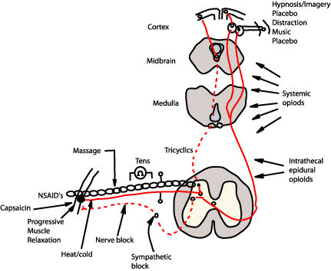

*A schematic showing sites of action of commonly used pharmacologic and behavioral analgesic therapies. Note especially all the sites for systemic opioids in the medulla (part of the brainstem) and midbrain. [All Care Visiting Nurse Association and Hospice]*

This schematic emphasizes that there are many ways to reduce the experience of pain. When the experience of pain is reduced temporarily, you have a choice of passively appreciating the reduction or actively using the reduction to increase activity and fun and begin reversing the downward spiral of pain/inactivity, as suggested by Daniel J. Clauw in his wonderful YouTube video, “Chronic Pain – Is it All in Their Head?” The connections down from the brain suggest possible mechanisms by which a retrained brain can reduce and eventually eliminate chronic pain.

The gate control theory of pain can explain how all the ways shown in the schematic can reduce the experience of pain. But it is not yet clear, at least to me, whether the gates are used by a retrained brain to eliminate chronic pain. Perhaps higher level mental processes that involve meaning and pain are more important.

## Meaning and Pain

The brain creates the sensation of pain while trying to help us! It unconsciously evaluates incoming sensory input based on meaning. If it feels that we really need to pay attention to some potentially harmful sensory input, it creates pain to alert us. This point is eloquently made in a story told by Prof. Lorimer Moseley, (a distinguished pain researcher who edited the “Graded Motion Imagery Handbook”) from 2:00 to about 9:00 in his YouTube video, “Body in mind – the role of the brain in chronic pain.” If you like the story, you can get his credentials at the first of the video and find some very interesting research studies after the story. This story is so important and entertaining that I do not want to spoil it for you by summarizing it here. I’ll just attempt to entice you by mentioning that it involves what turns out to be the third deadliest snake in the world.

The goal of watching this video and other videos suggested below, visiting the neuroplastix.com website, reading books from the bibliography below and doing research on your own is to come to a clear understanding that the solution to chronic pain is not just dealing with tissue, but retraining the brain. This clear understanding can provide the motivation to do the relentless work it may take to reduce your chronic pain. (Or you might get lucky and get a breakthrough very quickly like Susan did!)

## Sensitization and its reversal

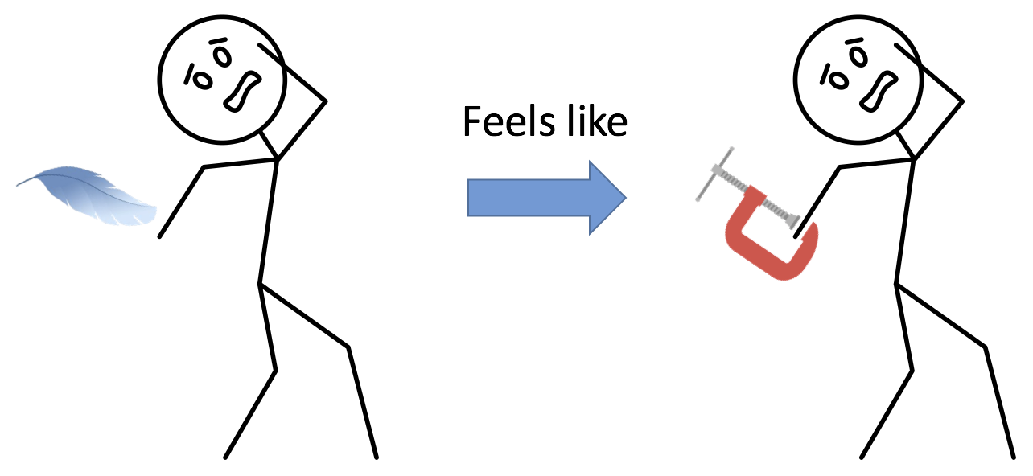

*After experiencing persistent pain, the body and brain can become so sensitized that even the touch of a feather is painful!*

Sensitization can be displayed graphically by plotting a person’s pain rating (from 0 to 10) as a noxious stimulus is increased.

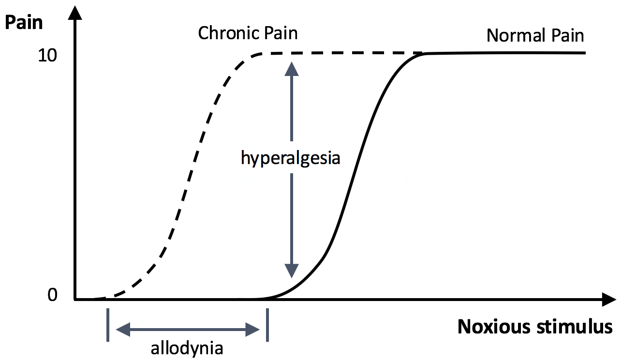

*Two key measures of sensitization are allodynia, reduction in pain threshold, and hyperalgesia, increased response to noxious stimulus.*

This figure shows what happens in chronic pain. The black curve shows how the body typically works. As a noxious stimulus is increased (think temperature of a block your hand is on or the force of a rod pressing against your leg) no pain is sensed until some threshold above which the pain increases. This helpful, nociceptive, pain is designed to minimize tissue damage.

The dashed curve (Chronic Pain) shows what goes wrong after the brain is sensitized by the prolonged experience of pain. A great story about how bad sensitization can get is in a YouTube video by Stanford physician Elliot Krane, “The mystery of chronic pain.” The video describes the sensitization to even the touch of a feather (as shown above), and continues with an important story concerning the agony of a young girl who became so sensitized that even a light touch caused excruciating, burning pain. It ends with her performing a cartwheel, free from pain, as a result of the work of desensitization he describes.

Researchers have begun to investigate why sensitization happens for some people, leading to chronic pain, while habituation happens for other people. That is, some people become more and more sensitized to repeated noxious stimulus while others just seem to adapt to it. One investigation concluded: “Personality should be seen as a context for modulating pain experience, and as such, a comprehensive evaluation of clinical pain patients should include ways to understand relevant personal styles and traits of an individual patient.” [Nakamura et al] Hopefully future research on this topic will lead to an understanding of optimal methods for retraining the brain away from pain depending on personality.

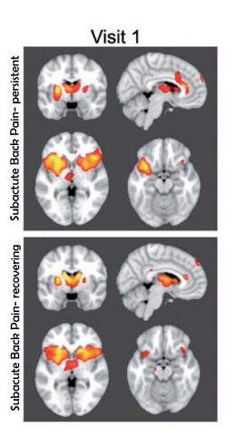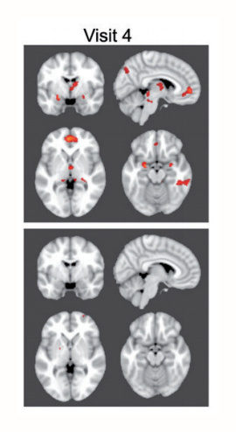

*Some people develop chronic pain and some don’t. The colored regions associated with the experience of pain were detected with functional Magnetic Resonance Imaging (fMRI). The top row has averaged results from patients whose pain on visit 1 evolved into chronic pain by visit 4 about a year later. The bottom row has averaged results from patients whose pain on visit 1 did not evolve into chronic pain as shown by the lack of colored regions in the lower right panel.*  *[Hashmi, et al.]*

The top right panel is important. The colored regions are the regions generating the experience of chronic pain. Those colored regions are the dragon we need to slay in order to overcome chronic pain.

# Four Useful Methods and the Science Behind Them

# Learning

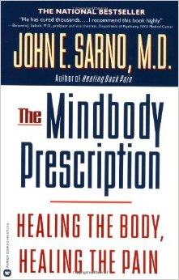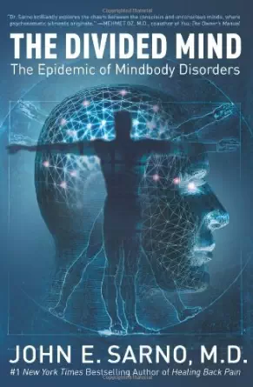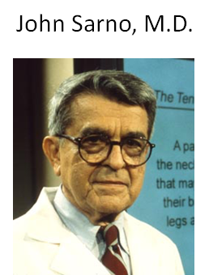

*These are the books that helped me retrain my brain.*

My own breakthrough from my five years of chronic pain came from watching YouTube videos and then reading books, starting with “The Mindbody Prescription: Healing the Body, Healing the Pain” by John Sarno, M.D. He advises patients who cannot visit him in person for his three hour healing lecture to just read his books over and over again until their pain goes away. The basic message of the videos and books is that the brain creates pain and therefore also possesses the ability to turn it off.

The method of Dr. Sarno involved listening to his lecture or reading his books to learn his theory of tension myositis syndrome (TMS), also known as tension myoneural syndrome. He hypothesizes that the brain attempts to help a person keep things, such as rage, from erupting from the unconscious into conscious awareness by distracting a person with the experience of pain. This is a method based in the complex, and growing, field of psychological influences on chronic pain [Hoffman]. He also hypothesizes that this pain is caused by the brain cutting off blood supply to nerves and other tissues thus creating pain in the tissues. This may happen sometimes, but may not be necessary since the brain seems able to create pain without any tissue problem (e.g., phantom leg pain). My personal experience was that despite my doubt, his approach worked for me!

There is peer-reviewed evidence for the usefulness of Dr. Sarno’s approach on the tmswiki: [tmswiki.org/ppd/An_Introduction_to_Tension_Myositis_Syndrome_(TMS)](http://www.tmswiki.org/ppd/An_Introduction_to_Tension_Myositis_Syndrome_(TMS)). There is also very useful information in the Wikipedia entry: Tension myositis syndrome.

Dr. Sarno himself, though retired, was kind enough to review the paragraphs I wrote about his work, including my idea that the brain did not need to create a body problem in order create the experience of pain. He wrote that my paragraphs: “reflect some of my ideas about chronic pain accurately, though incompletely”. One of the many things that make this document incomplete is that Dr. Sarno goes into detail about the psychological sources of chronic pain in his books. Clearly, if you choose to follow his method you need to go beyond the accurate, but incomplete, treatment in my paragraphs and read his books!

### Learning with Operant and Cognitive Behavioural Treatments (OBT and CBT)

Learning about yourself and your mental processes with psychotherapy can be especially effective if you can find a psychotherapist with experience in treating chronic pain [Jensen, MP] [Hoffman, BM] [Thieme et al.]. Multimodal treatment of chronic pain often includes operant and cognitive behavioural treatments.

In Operant Behavioural Treatment (OBT), patients are retrained with multiple sessions (of order 15) by a clinician, usually a psychologist or psychiatrist, to decrease observable pain behaviors. Pain behaviours have been defined as verbal and nonverbal behaviours that are used to communicate a problem to the environment [Fordyce, W]. They might include such behaviours as vocal responses like moans and gasps, motor behaviour such as hunched body postures, hand rubbing, grimacing, and limping, and avoidance behaviour such as avoiding work or social interactions [Mazzucchelli and Da Silva].

In Cognitive Behavioural Treatment (CBT), patients are retrained with multiple sessions (of order 15) by a clinician, usually a psychologist or psychiatrist, to decrease maladaptive thoughts and attitudes, such as catastrophizing (telling yourself that things are much worse than they actually are) [Thieme et al.]. CBT can deal with “thought viruses” that perpetuate pain such as a patient's belief that pain always equates to harm, resulting in reluctance to engage in activity or therapy [Peter, I., et al.].

OBT and CBT have been demonstrated to be more effective in long term reduction of chronic pain than passive treatments such as infrared heat therapy [Thieme et al.]. Though OBT and CBT both require a clinician, their focus is on active self-management of pain. This fits with the basic message of this document - move from passive to proactive! This document and most of its resources can help you do the work of recovering from chronic pain by retraining your brain in your own home. If, however, you are lucky enough to be able to find pain management specialists in your area and within your budget that use a multimodal approach including OBT or CBT, this may be a great alternative.

A systematic review and meta-analysis of randomized controlled trials of cognitive behaviour therapy and behaviour therapy for chronic pain in adults, excluding headache, found effect sizes of 0.33 for cognitive behavioral therapy and 0.32 for behavior therapy [Morley]. Several non-pharmacological interventions, particularly exercise and cognitive-behavioural therapy (CBT), have garnered good evidence of effectiveness as stand-alone, adjunctive treatments for patients with chronic pain [Hassett].

# 2. Activity

Based on a systematic review of randomized controlled trials (RCTs), aerobic exercise of low to moderate intensity, such as walking and pool exercise, can improve symptoms and distress in patients with chronic widespread pain and fibromyalgia [Mannerkorpi]. Another review concluded that physical activity significantly improves pain and related symptoms. Yet another found that yoga was good for lower back pain and Tai Chi for knee pain [[Nahin]](http://www.mayoclinicproceedings.org/article/S0025-6196(16)30317-2/pdf). For chronic pain, strict guidelines for physical activity are lacking, but frequent movement is preferable to sedentary behavior. This gives considerable freedom in prescribing physical activity treatments, which are most successful when tailored individually, progressed slowly and account for physical limitations, psychosocial needs and available resources [Ambrose].

If you are concerned about the danger of hurting yourself as you add activities, you might want to consider “Graded Motor Imagery” from [Neuro Orthopaedic Institute, NOI](https://www.youtube.com/channel/UCalAxRV5aU3Qaz0GIqq3_yQ), which was originally developed by pain experts, such as Prof. Lorimer Moseley for pain experts. Recently, however, apps for cell phones and a handbook on Graded Motor Imagery have become available to you. You could start with a YouTube video called “What is Graded Motor Imagery?” by the [Neuro Orthopaedic Institute, NOI](https://www.youtube.com/channel/UCalAxRV5aU3Qaz0GIqq3_yQ). Next, you could look at their handbook.

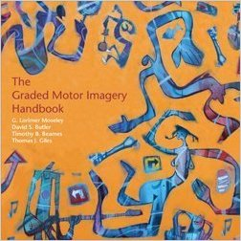

*This is a great handbook aimed at pain specialists, but accessible to the rest of us.*

The “Graded Motion Imagery Handbook” presents many tested techniques for safely reversing the downward spiral of pain/inactivity. It even has movie recommendations for retraining the brain! In chapter two, the editor, Prof. Lorimer Moseley recommends “Oscar Peterson, Music in the key of Oscar.” And “Shine.” These movies are recommended because they use the brain’s own motor neurons to help with retraining the brain.

There is also a chapter by David Butler on using metaphors such as “Motion is Lotion,” which can be really helpful in motivating us to reap the benefits of motion, and “Though I am sore, I am safe,” which I used for several days after some vigorous gardening that resulted in some lower back soreness. Just saying that like a mantra (also the shorter form “sore but safe”) minimized fear that the soreness I felt might persist. I took some ibuprofen so my brain would experience as little pain as possible. Two days later it was gone.

The chapter by Timothy Beames includes examples of useful images, mental visualization of motion and mirror box techniques. The final chapter, by Thomas Giles, introduces the noigroup, which you can join for free at [noigroup.com](http://www.noigroup.com/). The noigroup website has links to many, many helpful resources for retraining your brain. These include new apps for iPhones and Android such as “Recognise Shoulder” and “Recognise Back” for dealing with specific chronic pain conditions. You also find these apps by entering “noigroup” in a search on Google Play or the iPhone AppStore. Another website, [gradedmotorimagery.com](http://www.gradedmotorimagery.com/), tells about Graded Motor Imagery courses you can take with a professional.

The method of Graded Motor Imagery (the method of Lorimer Moseley and associates in the [Neuro Orthopaedic Institute, NOI](https://www.youtube.com/channel/UCalAxRV5aU3Qaz0GIqq3_yQ)) is based on imagining or seeing moving without pain. For example, a mirror box can be used to see a pain free right hand and its image that looks like a left hand. As the right hand moves, pain free, it appears to the brain that the left hand is moving pain free.

## Mirror box

Mirror box therapy was invented by Prof. [Vilayanur S. Ramachandran](https://en.wikipedia.org/wiki/Vilayanur_S._Ramachandran) to help patients with [phantom limb](https://en.wikipedia.org/wiki/Phantom_limb) [pain](https://en.wikipedia.org/wiki/Pain). A recent peer-reviewed paper, “The Effects of Graded Motor Imagery and Its Components on Chronic Pain: A Systematic Review and Meta-Analysis” [Bowering et al.], concludes that positive effects were observed for mirror therapy. Mirror therapy is effective for overcoming phantom limb pain [Chan].

## 

*This mirror box is offered on the Noigroup website with the description: “Mirrors may be used for a variety of pain and disability states especially involving the hands and feet. In particular, mirror therapy may be appropriate for problems such as complex regional pain syndrome, phantom limb pain, stroke and focal dystonia. Many people gain pain relief and better movement by using a mirror. The Mirror Box has had much success as a patient take-home resource.”*

[*noigroup.com/en/Store*](http://www.noigroup.com/en/Store)

There is peer-reviewed evidence for the usefulness of Graded Motor Imagery, especially mirror box therapy, which is sometimes included in Graded Motor Imagery, as in the Graded Motor Imagery workbook, but sometimes treated as a separate technique. There has even been a meta analysis of six randomized controlled trials [Bowering et al.].

## Qigong and Tai Chi

There is very strong clinical evidence for the effectiveness of Qigong and Tai Chi for overcoming chronic pain. A systematic review found that all randomly controlled studies (RCTs)

of Qigong demonstrated greater pain reductions in the qigong groups compared with

control groups. Meta-analysis of 2 RCTs showed a significant effect of external qigong compared with general care for treating chronic pain [Lee]. Another randomly controlled clinical trial demonstrated statistically significant results of immediate reductions in pain intensity in persons with chronic pain after the 2nd, 3rd, and 4th Qigong sessions. This finding is especially impressive given the long duration of pain (> 5 years), in most of the participants [Vincent].

A randomized controlled trial found that a 12-week course of Tai Chi appears to reduce pain and improve physical function, self-efficacy, depression, and health status for knee osteoarthritis [Wang]. Tai chi, yoga, hypnosis, and progressive muscle relaxation were significantly associated with pain reduction in several studies [Morone]. The primary finding of another systematic review and meta-analysis was that Tai Chi gave improvements in chronic pain for patients with osteoarthritis, OA, lower back pain, LBP, and osteoporosis.

# 3. Biofeedback

## How to Overcome Chronic Pain with Biofeedback

Biofeedback is a way to gain control of physical processes that are not normally under conscious control. For example, people can learn to warm their hands by watching a thermometer while focusing mental activity on trying to get the temperature to increase by consciously relaxing to increase blood flow to the hands. In general, instruments are used to give “biofeedback”, on temperature, pulse rate, electrical signals from muscle activation (EMG), electrical signals from the heart (EKG), electrical signals from the brain (EEG) etc. Usually biofeedback is done in the office of a professional who has professional equipment.

Biofeedback is an established technique for overcoming some forms of chronic pain [Fisher]. For example, it has been shown to be effective for 63% of people suffering from migraine headaches [Sargent]. The type of biofeedback used for this study was simply hand temperature! The participants were trained to say phrases like: “*I feel quite quiet . . . I am beginning to feel quite relaxed . . . My feet feel heavy and relaxed . . . My ankles, my knees, and my hips, feel heavy, relaxed, and comfortable . . . My solar plexus, and the whole central portion of my body, feel relaxed and quiet . . . My hands, my arms, and my shoulders feel heavy, relaxed and comfortable. . . . My neck, my jaws, and my forehead feel relaxed . . . They feel comfortable and smooth . . . My whole body feels quiet, heavy, comfortable and relaxed. I feel quite relaxed . . . My arms and hands are heavy and warm . . . I feel quite quiet . . . My whole body is relaxed and my hands are warm, relaxed and warm . . . My hands are warm . . . Warmth is flowing into my hands, they are warm . . . warm.”*[Sargent]. These experiments were done with a trainer, but since all that is needed is something to measure hand temperature, you, like many others, can do it at home.

I was personally trained to raise my hand temperature by a biofeedback expert at Sansum Clinic with similar phrases. It is now easy for me to do it on my own with a thermometer and my experience is that most people could learn to do it with practice. An electronic thermometer with a digital display is convenient. For example, the Temperature Biofeedback Digital Numeric Thermal Trainer available for $21.95 at Amazon works well for me. It took me about 4 ten minute sessions to learn to do it. The people I know who have used it to overcome chronic pain have done it three or more times a day.

Several other types of biofeedback have also been shown clinically to be effective for chronic pain. A 2016 Meta-analysis concluded: “*This is the first meta-analysis on the efficacy of biofeedback treatment for chronic back pain using the current standard recommendations to examine the following outcomes: pain intensity, reduction of muscle tension (EMG), depression, cognitive coping, and disability. The present results indicated that except for disability, (additional) biofeedback treatment led to improvements on all outcome measures in the short and long terms.*”[[Sielski]](https://www.researchgate.net/profile/Robert_Sielski2/publication/304006931_Efficacy_of_Biofeedback_in_Chronic_back_Pain_a_Meta-Analysis/links/576901d008ae7f0756a2320e.pdf) An earlier systematic review and meta-analysis of randomized controlled trials found, for example, an effect size of 0.74 for EMG biofeedback [Morley]. A 2016 Nature Reviews article looked at many types of closed-loop brain training: the science of neurofeedback [Sitaram].

The significance of Biofeedback training is not only that it can help with chronic pain directly, but more fundamentally that it shows that it is possible to gain control over normally unconscious processes such as hand temperature or heart rate or muscle tension. **This is what we want to achieve: control over the normally unconscious process of generating the experience of Pain. This is the goal of Retraining the Brain away from Chronic Pain.**

## Biofeedback with real time functional Magnetic Resonance Imaging, rtfMRI

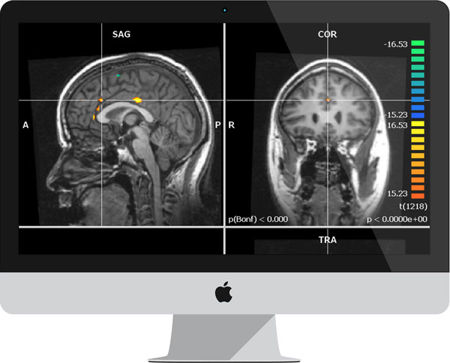

*fMRI, functional Magnetic Resonance Imaging, has been used to image the activation patterns in the brain in real time [image from Omneuron’s website]*

There have been many peer-reviewed research studies about imaging pain, including chronic pain, with fMRI [a review and meta analysis: Peyron, et al.] [Otti et al.][Kupers, et al.]. But of even more significance for chronic pain patients has been the use of real time functional Magnetic Resonance Imaging, rtfMRI, as a feedback gadget for retraining the brain. Using rtfMRI, chronic pain patients were trained to control activation in the rostral anterior cingulate cortex (rACC) and reported decreases in the ongoing level of chronic pain after training. [deCharms, et al.] The first author of that paper, Christopher deCharms, is now CEO of *Omneuron*, a life sciences company focusing on new technologies for measuring and changing brain function based on rtfMRI feedback ([omneuron.com/about](http://www.omneuron.com/about)). It has been reported, based on fMRI imaging, that the areas involved in different sorts of pain can be different [Makin, S] [Wagner, T] and that in chronic pain there is a growing involvement of areas involving emotion [Baliki, M N]. But fMRI studies of chronic pain are in their infancy.

# 4. Guided Mental Imagery and Meditation

The Neuroplastix method (the method on [neuroplastix.com](http://neuroplastix.com/) by Michael Moskowitz, M.D., and Marla Golden, D.O.,) involves visualizing areas of brain activity associated with chronic pain decreasing in size. It was discussed in some detail above in the section on Chronic Pain Therapy Grounded in Neuroplasticity. It involves visualizing areas of brain activity associated with chronic pain decreasing in size. It has been reported, based on fMRI imaging, that the areas involved in different sorts of pain can be different [Makin, S] [Wagner, T] and that in chronic pain there is a growing involvement of areas involving emotion [Baliki, M N]. But fMRI studies of chronic pain are in their infancy.

Dr. Moskowitz wrote to me: “fMRI readings are only part of our work. Before there were fMRIs

the areas of the brain that are major pain processing and perceiving regions were mapped out,

using other scientific techniques and approaches. fMRI is very helpful, but just another tool in

refining and confirming other science in the understanding of how the brain works. Dr. Golden

and I have scoured applicable literature on Neuroplasticity and our research has taken us to an

incredible body of cross discipline work ranging from basic neuroscience to clinical science. We

covered everything from physiology to genetic science in researching and writing up our work.

This work has yielded many ideas of how to help people, and we were fortunate to have large

numbers of patients to work with us on these approaches. We did not take the route of doing

our own randomized double blind trials, because the concept is too large to control enough

variables to do these types of studies, honestly. Our goal, instead, has been to gather the

information that has already been tested in various scientific manners and to pull together these

ideas across disciplines to come up with out approaches.”

Thus, there is evidence that this method is useful because: 1) it was gathered from already

tested information, 2) Drs. Moskowitz and Golden have documented the experiences of the

many people in the “Neuroplastic Transformation Workbook,” available at neuroplastix.com , and 3) It worked (very quickly) for Susan!

There are two main types of mindfulness meditation: focused attention, most typically on the breath, and open monitoring, being receptive to whatever arises moment by moment [Wallace]. Both of these have been shown to be helpful for dealing with pain. Focused attention has been shown to significantly reduce pain intensity ratings and pain unpleasantness ratings [Zeidan, Fadel]. Open monitoring has been shown to reduce pain unpleasantness but not pain intensity ratings [Brown CA, Jones AK]. Thus both types of mindfulness meditation can reduce the unpleasantness of pain. As the Dalai Lama said, “Pain is inevitable. Suffering is optional.” I currently understand this as, “Acute pain is inevitable. Suffering is optional. Chronic pain can be overcome.”

Zeiden and Fadel conclude: “Focused attention may attenuate pain by altering the elaboration of nociceptive information into pain, whereas open monitoring promotes a non evaluative stance to a fully experienced sensory event.” This seems especially important in light of recent fMRI imaging research that concludes, “Brain activity related to the perception of back pain shifts in location from regions involved in acute pain to engage emotion circuitry as the condition persists.” [Hashmi, et al.]

A 2016 [study](http://jamanetwork.com/journals/jama/fullarticle/2504811) that included Mindfulness-based stress reduction (MBSR) and Cognitive Behavioural Therapy (CBT) concluded: “*Among adults with chronic low back pain, treatment with MBSR or CBT, compared with usual care, resulted in greater improvement in back pain and functional limitations at 26 weeks, with no significant differences in outcomes between MBSR and CBT. These findings suggest that MBSR may be an effective treatment option for patients with chronic low back pain*.”

People have also looked at the brain activity that is enhanced by meditation. Newberg et al. found that “there is increased blood being pumped into the prefrontal cortex and the anterior cingulate gyrus after participating in the meditation practice”. Engström et. al. found that compassion meditation increased “activation in the left medial prefrontal cortex extending to the anterior cingulate gyrus.” Thus one way of looking at brain retraining is to replace undesirable mental activity, for example, generating the experience of chronic pain, with desirable mental activity, for example, generating the experience of compassion by using a practice, for example, meditation.

Dr. Christiane Wolf has a wonderful [blog](http://www.christianewolf.com/2017/01/transforming-chronic-pain/) about *Transforming Chronic Pain with Mindfulness and Compassion.* It contains a great section on practices suggesting work with the RAIN acronym:

* *R- Recognize*
* *A – Acknowledge, Allow*
* *I – Investigate with kindness*
* *N- Non-identify*

As currently presented in the scientific literature, meditation is seen as a treatment, not a cure for chronic pain. But the literature does clearly document that the brain can be retrained with meditation to control the experience of pain in the moment. It is not a giant leap beyond this to believe that the brain can control the experience of pain more generally.

From a neuroplastic perspective, if we keep our focused attention on something other than pain, the pain is not experienced as much of the time. And recall that neurons that fire together wire together. So not experiencing pain as much of the time will not only help keep the pain from increasing, it will actually help decrease it because it is also true that neurons that don’t fire together don’t wire together. Thus it is not really a good idea to stoically endure pain, but rather, especially once one knows that there is no benefit to experiencing the pain, to reducing the pain with drugs or rubbing (especially in the acute phase), and meditation or visualization or distraction (especially in the chronic phase).

|  |
| --- |
| Transcutaneous electrical nerve stimulation (TENS)? Transcutaneous Electrical Nerve Stimulation (TENS) has been widely used for the treatment of pain in general, including chronic pain. Inexpensive units can be purchased for under $25 at drugstores or online. They are generally intended to be placed on or near the painful part of the body.    <!--1.5-->Reclaim your life with doctor recommended pain relief.  *Recently a very advanced TENS unit, Quell, was approved by the FDA for chronic pain for both daytime and sleep (quellrelief.com). The comments on Amazon suggest that this unit has been very helpful for many people, even for neuropathy and lower back pain. The manufacturer says that the mechanism is the stimulation of production of endorphins, the body's natural opioids. Thus, though it is worn on the leg, it works even for pain that is not in the leg since it uses the general opioid gates in the lower brain rather than the specific gates along the spine.*  The question mark in the heading of this section is because TENS has not generally been used for retraining the brain, but for temporary pain relief. Perhaps the benefit of TENS could be enhanced with the idea that you are choosing to use TENS, or any other temporary relief method, as a way of retraining your brain that it is not important to pay attention to the chronic pain. You find out that you do just fine, probably better, without the “benefit” of the pain so why choose to pay attention to the pain and thus strengthen it? Acupuncture, hypnosis and psychoactive drugs [Acupuncture](https://www.ncbi.nlm.nih.gov/pmc/articles/PMC4036643/), hypnosis and some psychoactive drugs such as amitriptyline and Lyrica can help with the brain problem of chronic pain. The focus of this document is, however, is on therapies you can do yourself. I made an exception and did include Cognitive Behavioural Therapy because it is so effective and because, like all the other treatments presented here, it is something you do, not something done to you. You heal yourself with the help of a therapist.  This is in agreement with one of the conclusions from the [National Pain Strategy](https://iprcc.nih.gov/docs/DraftHHSNationalPainStrategy.pdf): “*Self-management programs can improve quality of life and is an important component of acute and chronic pain prevention and management*.” Summary and Action Plan A useful metaphor is: Once you have consulted with computer experts and decided on an appropriate level of virus protection for your computer, then you want to turn off annoying and useless pop-ups that arrive on your computer screen interrupting you with, “It’s time to upgrade your virus protection to Platinum or you are in serious danger!” You believe that it is possible to prevent the pop-ups by changing “settings,” but for now you just X them out individually. Chronic pain is like those annoying pop-ups. We’d like to figure out how to change our brain’s settings so chronic pain does not even come into our awareness, but until we find how to reset the settings, we can X them out individually.  If you are at the stage of X-ing them out individually, there are proven methods you can employ.   1. Meditate with a goal of refocusing your attention on one thing (focused awareness) or many things (open awareness), but not pain. See if it helps decrease the negative emotions normally associated with pain, if not the pain intensity. 2. Try TENS, perhaps enhanced with the idea that you are choosing to use TENS, or any other temporary relief method, as a way of retraining your brain that it is not important to pay attention to the chronic pain. You do just fine, in fact probably better, without the “benefit” of the pain so why choose to pay attention to the pain? 3. Use a sling or other way to stop doing anything that ignites pain, at least temporarily, until any tissue inflammation has had time to go away or the body has healed itself in some other way. 4. Start any activity where you can lose yourself like walking in nature, looking around actively, music, sex, watching movies, video games, virtual reality, intense tastes, sudoku, golf, painting, dancing. The key is that the stimulation from the activity needs to be great enough to be more interesting to the brain than the pain. If you find yourself still mostly focused on your chronic pain during the activity, perhaps try something else. 5. Use prescribed drugs to enable beginning helpful, safe activities that would not be possible otherwise.   If you become really committed to “resetting the settings” then it is time to come up with your own action plan to deal with your chronic pain in a way that can cure it, not just relieve it temporarily. A sample action plan is:   1. Read and reread Dr. Sarno’s books and/or watch videos about his approach until you have a breakthrough of using your brain to stop pain. You can also find lots of useful information about his approach and find practitioners at [www.tmswiki.org](http://www.tmswiki.org). 2. Resume normal and gentle activities. You can start gradually with Graded Mental Imagery from [Neuro Orthopaedic Institute](https://www.youtube.com/channel/UCalAxRV5aU3Qaz0GIqq3_yQ) if you are afraid of moving. When you are ready, Qigong and Tai Chi can really help! 3. Practice warming your hands to 95 degrees F. three times a day. 4. Visit the [neuroplastix.com](http://neuroplastix.com/) website and learn, for example, to visualize pain centers in the brain decreasing in size. Consider purchasing the excellent workbook available on the website.   Soon, I hope and believe, the idea of retraining the brain away from pain will be well enough accepted that more grant proposals will be funded, more scientific papers will be written, and more pain specialists will become specialists in retraining the brain. Then there can be expert consensus panels and increasing knowledge about optimum methods for specific situations and personalities. But what can you do until this happens?  You can follow the example of the thousands of people who have already become proactive, developed their own action plan and overcame their chronic pain. I want to encourage you. You can do it too and overcome your chronic pain. |

# Resources

## Useful YouTube Videos

Allan Basbaum - Pain and the Brain - Wonderful overview of pain from a leading expert at UCSF.

Christopher deCharms Ted Talks - A look into the brain using fMRI for chronic pain patients Has wonderful images of the brain experiencing pain and describes using fMRI as a feedback device for retraining the brain.

Daniel J. Clauw M.D. Chronic Pain – Is it All in Their Head? Wonderful material about the downward spiral of pain/(inactivity, lack of sleep, stress) and its reversal starting 1:14 after a great discussion about the differences between chronic “brain pain” and acute (nociceptive) pain.

Elliot Krane M.D. The mystery of chronic pain. This video has a wonderfully informative story about sensitization and its reversal in a young woman.

Lorimer Moseley M.D. Body in mind - the role of the brain in chronic pain. This has a great story about how meaning affects the experience of pain starting at 2:00, but I recommend watching the whole thing for some of the first research studies that are relevant to retraining the brain.

# John E Sarno M.D. - 20/20 Segment. This short video and his books helped me overcome my chronic pain by convincing me that the source of my pain had become my brain.

# John E. Sarno M.D. On The Howard Stern Show. Documents how retraining your brain can dramatically improve your quality of life.

# [Neuro Orthopaedic Institute NOI](https://www.youtube.com/channel/UCalAxRV5aU3Qaz0GIqq3_yQ) - *What is Graded Motor Imagery?*

Silje Endersen Reme *Pain, Is it all in your mind?* This TED talk supports Dr. Sarno’s idea that underlying psychological issues can be a major factor in back pain

## Useful Books

Doidge, Norman. *The Brain's Way of Healing: remarkable discoveries and recoveries from the frontiers of neuroplasticity*. Penguin Books, 2016.

Morowitz, Michael and Golden, Marla, *Neuroplastic Transformation Workbook*, available at [Neuroplastix.com](http://neuroplastix.com/)

Moseley, G. Lorimer. *The graded motor imagery handbook*. Noigroup publications, 2012.

Sarno, John E. *Healing back pain: The mind-body connection*. Grand Central Publishing, 2001. Sarno, John E. *The mindbody prescription: Healing the body, healing the pain*. Grand Central Publishing, 2001.

Sarno, John E. *The divided mind*. Harper Collins, 2009.

## Useful Websites

This is the website with the images that Susan used for her breakthrough: [Neuroplastix.com](http://neuroplastix.com/)

A great website for Dr. Sarno’s approach that includes a link to medical evidence: [tmswiki.org/ppd/An_Introduction_to_Tension_Myositis_Syndrome_(TMS)](http://www.tmswiki.org/ppd/An_Introduction_to_Tension_Myositis_Syndrome_(TMS))

There is lots of information about Graded Motor Imagery at [gradedmotorimagery.com/](http://www.gradedmotorimagery.com/) and evidence-based multimedia resources and courses for the treatment of pain at [**noi**group.com/](http://www.noigroup.com/).

All Care Visiting Nurse Association and Hospice has a wonderful web document on the modern theory of pain. [allcare.org/CancerPain-and-SymptomManagement/comfort/cfm2/cfm2_cont.htm#5e](http://www.allcare.org/CancerPain-and-SymptomManagement/comfort/cfm2/cfm2_cont.htm#5e)

[NIH MedlinePlus] [nlm.nih.gov/medlineplus/magazine/issues/spring11/articles/spring11pg5-6.html](https://www.nlm.nih.gov/medlineplus/magazine/issues/spring11/articles/spring11pg5-6.html)

This National Institutes of Health MedlinePlus web page gives the definition of chronic pain used here and states: “Self-management of chronic pain holds great promise as a treatment approach.”

## Scientific Publications

Ambrose, Kirsten R., and Yvonne M. Golightly. "Physical exercise as non-pharmacological treatment of chronic pain: Why and when." Best Practice & Research Clinical Rheumatology 29.1 (2015): 120-130.

Amin, H., Maccione, A., Marinaro, F., Zordan, S., Nieus, T. and Berdondini, L., 2016. Electrical responses and spontaneous activity of human iPS-derived neuronal networks characterized for 3-month culture with 4096-electrode arrays. *Frontiers in neuroscience*, *10*, p.121.

Baliki, Marwan N., et al. "Chronic pain and the emotional brain: specific brain activity associated with spontaneous fluctuations of intensity of chronic back pain." *The Journal of Neuroscience* 26.47 (2006): 12165-12173.

Baliki, M.N., Geha, P.Y., Fields, H.L. and Apkarian, A.V., 2010. Predicting value of pain and analgesia: nucleus accumbens response to noxious stimuli changes in the presence of chronic pain. Neuron, 66(1), pp.149-160.

Baliki, M.N., Mansour, A.R., Baria, A.T. and Apkarian, A.V., 2014. Functional reorganization of the default mode network across chronic pain conditions. PloS one, 9(9), p.e106133.

Bowering, K. Jane, Neil E. O'Connell, Abby Tabor, Mark J. Catley, Hayley B. Leake, G. Lorimer Moseley, and Tasha R. Stanton. "The effects of graded motor imagery and its components on chronic pain: a systematic review and meta-analysis." *The Journal of Pain* 14, no. 1 (2013): 3-13.

Brown CA, Jones AK (2010) Meditation experience predicts less negative appraisal of pain: electrophysiological evidence for the involvement of anticipatory neural responses. Pain 150:428 –438.

Kabat-Zinn, Jon, Leslie Lipworth, and Robert Burney. "The clinical use of mindfulness meditation for the self-regulation of chronic pain." *Journal of behavioral medicine* 8.2 (1985): 163-190.

Chan, Brenda L., et al. "Mirror therapy for phantom limb pain." New England Journal of Medicine 357.21 (2007): 2206-2207

Chou, R., Turner, J.A., Devine, E.B., Hansen, R.N., Sullivan, S.D., Blazina, I., Dana, T., Bougatsos, C. and Deyo, R.A., 2015. The effectiveness and risks of long-term opioid therapy for chronic pain: a systematic review for a National Institutes of Health Pathways to Prevention Workshop. *Annals of internal medicine*, *162*(4), pp.276-286.

Chapman, C.R. and Nakamura, Y., 1999. A passion of the soul: an introduction to pain for consciousness researchers. *Consciousness and cognition*, *8*(4), pp.391-422.

Crow JM, (2016) Biomedicine: Move over, morphine. Nature 535, S4-S6

deCharms, Christopher, et al. "Control over brain activation and pain learned by using real-time functional MRI." *Proceedings of the National Academy of Sciences of the United States of America* 102.51 (2005): 18626-18631.

Denk, Franziska, Stephen B. McMahon, and Irene Tracey. "Pain vulnerability: a neurobiological perspective." *Nature neuroscience* 17.2 (2014): 192-200.

Engström, Maria, and Birgitta Söderfeldt. "Brain activation during compassion meditation: a case study." *The Journal of Alternative and Complementary Medicine* 16.5 (2010): 597-599.

Farmer, M.A., Baliki, M.N. and Apkarian, A.V., 2012. A dynamic network perspective of chronic pain. *Neuroscience letters*, *520*(2), pp.197-203.

Fisher, Johnnie G., John P. Hatch, and John D. Rugh, eds. *Biofeedback: Studies in clinical efficacy*. Springer Science & Business Media, 2013.

Fordyce, Wilbert Evans. *Behavioral methods for chronic pain and illness*. CV Mosby, 1976.

Gaskin, Darrell J., and Patrick Richard. "The economic costs of pain in the United States." *The Journal of Pain* 13.8 (2012): 715-724.

Gozani, Shai N. "Science Behind Quell™ Wearable Pain Relief Technology for Treatment of Chronic Pain." ©2015 NeuroMetrix, Inc. All Rights Reserved. PN 2204114 Rev. B

Hashmi, J.A., Baliki, M.N., Huang, L., Baria, A.T., Torbey, S., Hermann, K.M., Schnitzer, T.J. and Apkarian, A.V., 2013. Shape shifting pain: chronification of back pain shifts brain representation from nociceptive to emotional circuits. *Brain*, *136*(9), pp.2751-2768.

Hassett, Afton L., and David A. Williams. "Non-pharmacological treatment of chronic widespread musculoskeletal pain." Best practice & research Clinical rheumatology 25.2 (2011): 299-309.

Hoffman, Benson M., Rebecca K. Papas, David K. Chatkoff, and Robert D. Kerns. "Meta-analysis of psychological interventions for chronic low back pain." *Health psychology* 26, no. 1 (2007): 1.

Holmes, David, (2016) “The pain drain” Nature 535,S2-S3

Jensen, Mark P., et al. "Coping with chronic pain: a critical review of the literature." *Pain* 47.3 (1991): 249-283.

Kong, Ling Jun, et al. "Tai Chi for Chronic Pain Conditions: A Systematic Review and Meta-analysis of Randomized Controlled Trials." Scientific reports 6 (2016).

Kucyi A. & Davis K. D. The dynamic pain connectome. Trends Neurosci. 38, 86–95 (2015).

Kupers, Ron, and Henrik Kehlet. "Brain imaging of clinical pain states: a critical review and strategies for future studies." *The Lancet Neurology* 5.12 (2006): 1033-1044.

Lee, Myeong Soo, Max H. Pittler, and Edzard Ernst. "External qigong for pain conditions: a systematic review of randomized clinical trials." The Journal of Pain 8.11 (2007): 827-831.

Lee, M., Manders, T.R., Eberle, S.E., Su, C., D'amour, J., Yang, R., Lin, H.Y., Deisseroth, K., Froemke, R.C. and Wang, J., 2015. Activation of corticostriatal circuitry relieves chronic neuropathic pain. *Journal of Neuroscience*, *35*(13), pp.5247-5259.

Mannerkorpi, Kaisa, and Chris Henriksson. "Non-pharmacological treatment of chronic widespread musculoskeletal pain." Best Practice & Research Clinical Rheumatology 21.3 (2007): 513-534.

Mano, Hiroaki, and Ben Seymour. "Pain: a distributed brain information network?." PLoS Biol 13.1 (2015): e1002037.

Makin, S (2016) “Imaging: Show me where it hurts.” *Nature* **535**, S8–S9

Mazzucchelli, T.G. and Da Silva, M., 2016. The potential of behavioural activation for the treatment of chronic pain: An exploratory review. *Clinical Psychologist*, *20*(1), pp.5-16.

[Melzack R](http://melzack), [Wall PD](https://en.wikipedia.org/wiki/Patrick_David_Wall). [Pain mechanisms: a new theory](http://www.hnehealth.nsw.gov.au/__data/assets/pdf_file/0012/70122/pain_mechanisms_20100315013844.pdf). *Science*. 1965;150(3699):971–9

Morley, Stephen, Christopher Eccleston, and Amanda Williams. "Systematic review and meta-analysis of randomized controlled trials of cognitive behaviour therapy and behaviour therapy for chronic pain in adults, excluding headache." Pain 80.1 (1999): 1-13.

Morone, Natalia E., and Carol M. Greco. "Mind–body interventions for chronic pain in older adults: A structured review." Pain Medicine 8.4 (2007): 359-375.

Moseley, G. L. "A pain neuromatrix approach to patients with chronic pain."*Manual therapy* 8.3 (2003): 130-140.

Moskowitz, M. H. "Central influences on pain." *Interventional spine. An algorithmic approach. Saunders Elsevier, Philadelphia* (2008): 39-52.

Nahin, R.L., Boineau, R., Khalsa, P.S., Stussman, B.J. and Weber, W.J., 2016, September. Evidence-based evaluation of complementary health approaches for pain management in the United States. In *Mayo Clinic Proceedings* (Vol. 91, No. 9, pp. 1292-1306). Elsevier.

Nakamura, Y., Donaldson, G.W. and Okifuji, A., 2014. Personality, Anxiety, and Individual Variation in Psychophysiological Habituation and Sensitization to Painful Stimuli. *Journal of Pain & Relief*, *2014*.

Newberg, Andrew B., et al. "Meditation and neurodegenerative diseases." *Annals of the New York Academy of Sciences* 1307.1 (2014): 112-123.

Odawara, A., Katoh, H., Matsuda, N. and Suzuki, I., 2016. Physiological maturation and drug responses of human induced pluripotent stem cell-derived cortical neuronal networks in long-term culture. *Scientific reports*, *6*.

Otti, Alexander, Harald Guendel, Peter Henningsen, Claus Zimmer, and Michael Noll-Hussong. "Functional network connectivity of pain-related resting state networks in somatoform pain disorder: an exploratory fMRI study." *Journal of psychiatry & neuroscience: JPN* 38, no. 1 (2013): 57.

Peter, I., Wu, K., Meleger, A., Witkower, A., Mondale, T. and Borg-Stein, J., 2015. Nonpharmacologic Options for Treating Acute and Chronic Pain.*PM&R*, *7*(11), pp.S278-S294.

Peyron, R., B. Laurent, and L. Garcia-Larrea. "Functional imaging of brain responses to pain. A review and meta-analysis (2000)." *Neurophysiologie Clinique/Clinical Neurophysiology* 30.5 (2000): 263-288.

Rainville, P., Duncan, G.H., Price, D.D., Carrier, B. and Bushnell, M.C., 1997. Pain affect encoded in human anterior cingulate but not somatosensory cortex. *Science*, *277*(5328), pp.968-971.

Ren, W., Centeno, M.V., Berger, S., Wu, Y., Na, X., Liu, X., Kondapalli, J., Apkarian, A.V., Martina, M. and Surmeier, D.J., 2016. The indirect pathway of the nucleus accumbens shell amplifies neuropathic pain. *Nature neuroscience*, *19*(2), pp.220-222.

Sielski, R., Rief, W. and Glombiewski, J.A., 2016. Efficacy of biofeedback in chronic back pain: a meta-analysis. *International Journal of Behavioral Medicine*, pp.1-17.

Sargent, Joseph D., Elmer E. Green, and Dale E. Walters. "Preliminary report on the use of autogenic feedback training in the treatment of migraine and tension headaches." *Psychosomatic Medicine* 35.2 (1973): 129-135.

Schechter, David, et al. "Outcomes of a mind-body treatment program for chronic back pain with no distinct structural pathology-A case series of patients diagnosed and treated as tension myositis syndrome." *Alternative therapies in health and medicine* 13.5 (2007): 26.

Sitaram R, Ros T, Stoeckel L, Haller S, Scharnowski F, Lewis-Peacock J, Weiskopf N, Blefari ML, Rana M, Oblak E, Birbaumer N. Closed-loop brain training: the science of neurofeedback. Nature Reviews Neuroscience. 2016 Dec 22.

Thieme, K., Turk, D.C., Gracely, R.H. and Flor, H., 2016. Differential psychophysiological effects of operant and cognitive behavioural treatments in women with fibromyalgia. *European Journal of Pain*.

Tracey I, Bushnell MC. How neuroimaging studies have challenged us to rethink: Is chronic pain a disease? J Pain 2009;10:1113–20.

Vachon-Presseau, E., Tétreault, P., Petre, B., Huang, L., Berger, S.E., Torbey, S., Baria, A.T., Mansour, A.R., Hashmi, J.A., Griffith, J.W. and Comasco, E., 2016. Corticolimbic anatomical characteristics predetermine risk for chronic pain. *Brain*, *139*(7), pp.1958-1970.

Vincent, Ann, et al. "External qigong for chronic pain." The American journal of Chinese medicine 38.04 (2010): 695-703.

Wager, T.D., Atlas, L.Y., Lindquist, M.A., Roy, M., Woo, C.W. and Kross, E., 2013. An fMRI-based neurologic signature of physical pain. *New England Journal of Medicine*, *368*(15), pp.1388-1397.

Wager, T.D., Rilling, J.K., Smith, E.E., Sokolik, A., Casey, K.L., Davidson, R.J., Kosslyn, S.M., Rose, R.M. and Cohen, J.D., 2004. Placebo-induced changes in FMRI in the anticipation and experience of pain. *Science*, *303*(5661), pp.1162-1167.

Wallace BA (2006) The attention revolution: unlocking the power of the focused mind.

Wang, Chenchen, et al. "Tai Chi is effective in treating knee osteoarthritis: a randomized controlled trial." Arthritis Care & Research 61.11 (2009): 1545-1553.

Wiech, Katja. "Deconstructing the sensation of pain: The influence of cognitive processes on pain perception." Science 354.6312 (2016): 584-587.

Woo CW, Schmidt L, Krishnan A, Jepma M, Roy M, Lindquist MA, Atlas LY, Wager TD. Quantifying cerebral contributions to pain beyond nociception. Nature Communications. 2017;8.

Woolf CJ, Salter MW. Neuronal plasticity: Increasing the gain in pain. Science 2000;288:1765–9.

Zeidan, Fadel, et al. "Brain mechanisms supporting the modulation of pain by mindfulness meditation." *The Journal of Neuroscience* 31.14 (2011): 5540-5548.

Pamela Benham (figures and ideas), Daniel Bridges (figures, ideas and editing), Ray Enslow (editing), Katiana O’Dowd (editing and figure), Ken Pfeiffer (feedback) and (Your Name Goes Here if you help with this document!) helped create this document.